**COMP9331 Lab4**

Z5145114

Xiaodan Wang

**Exercise 1: Understanding TCP using Wireshark**

***Question 1 .*** *What is the IP address of gaia.cs.umass.edu? On what port number is it sending and receiving TCP segments for this connection? What is the IP address and TCP port number used by the client computer (source) that is transferring the file to gaia.cs.umass.edu?*

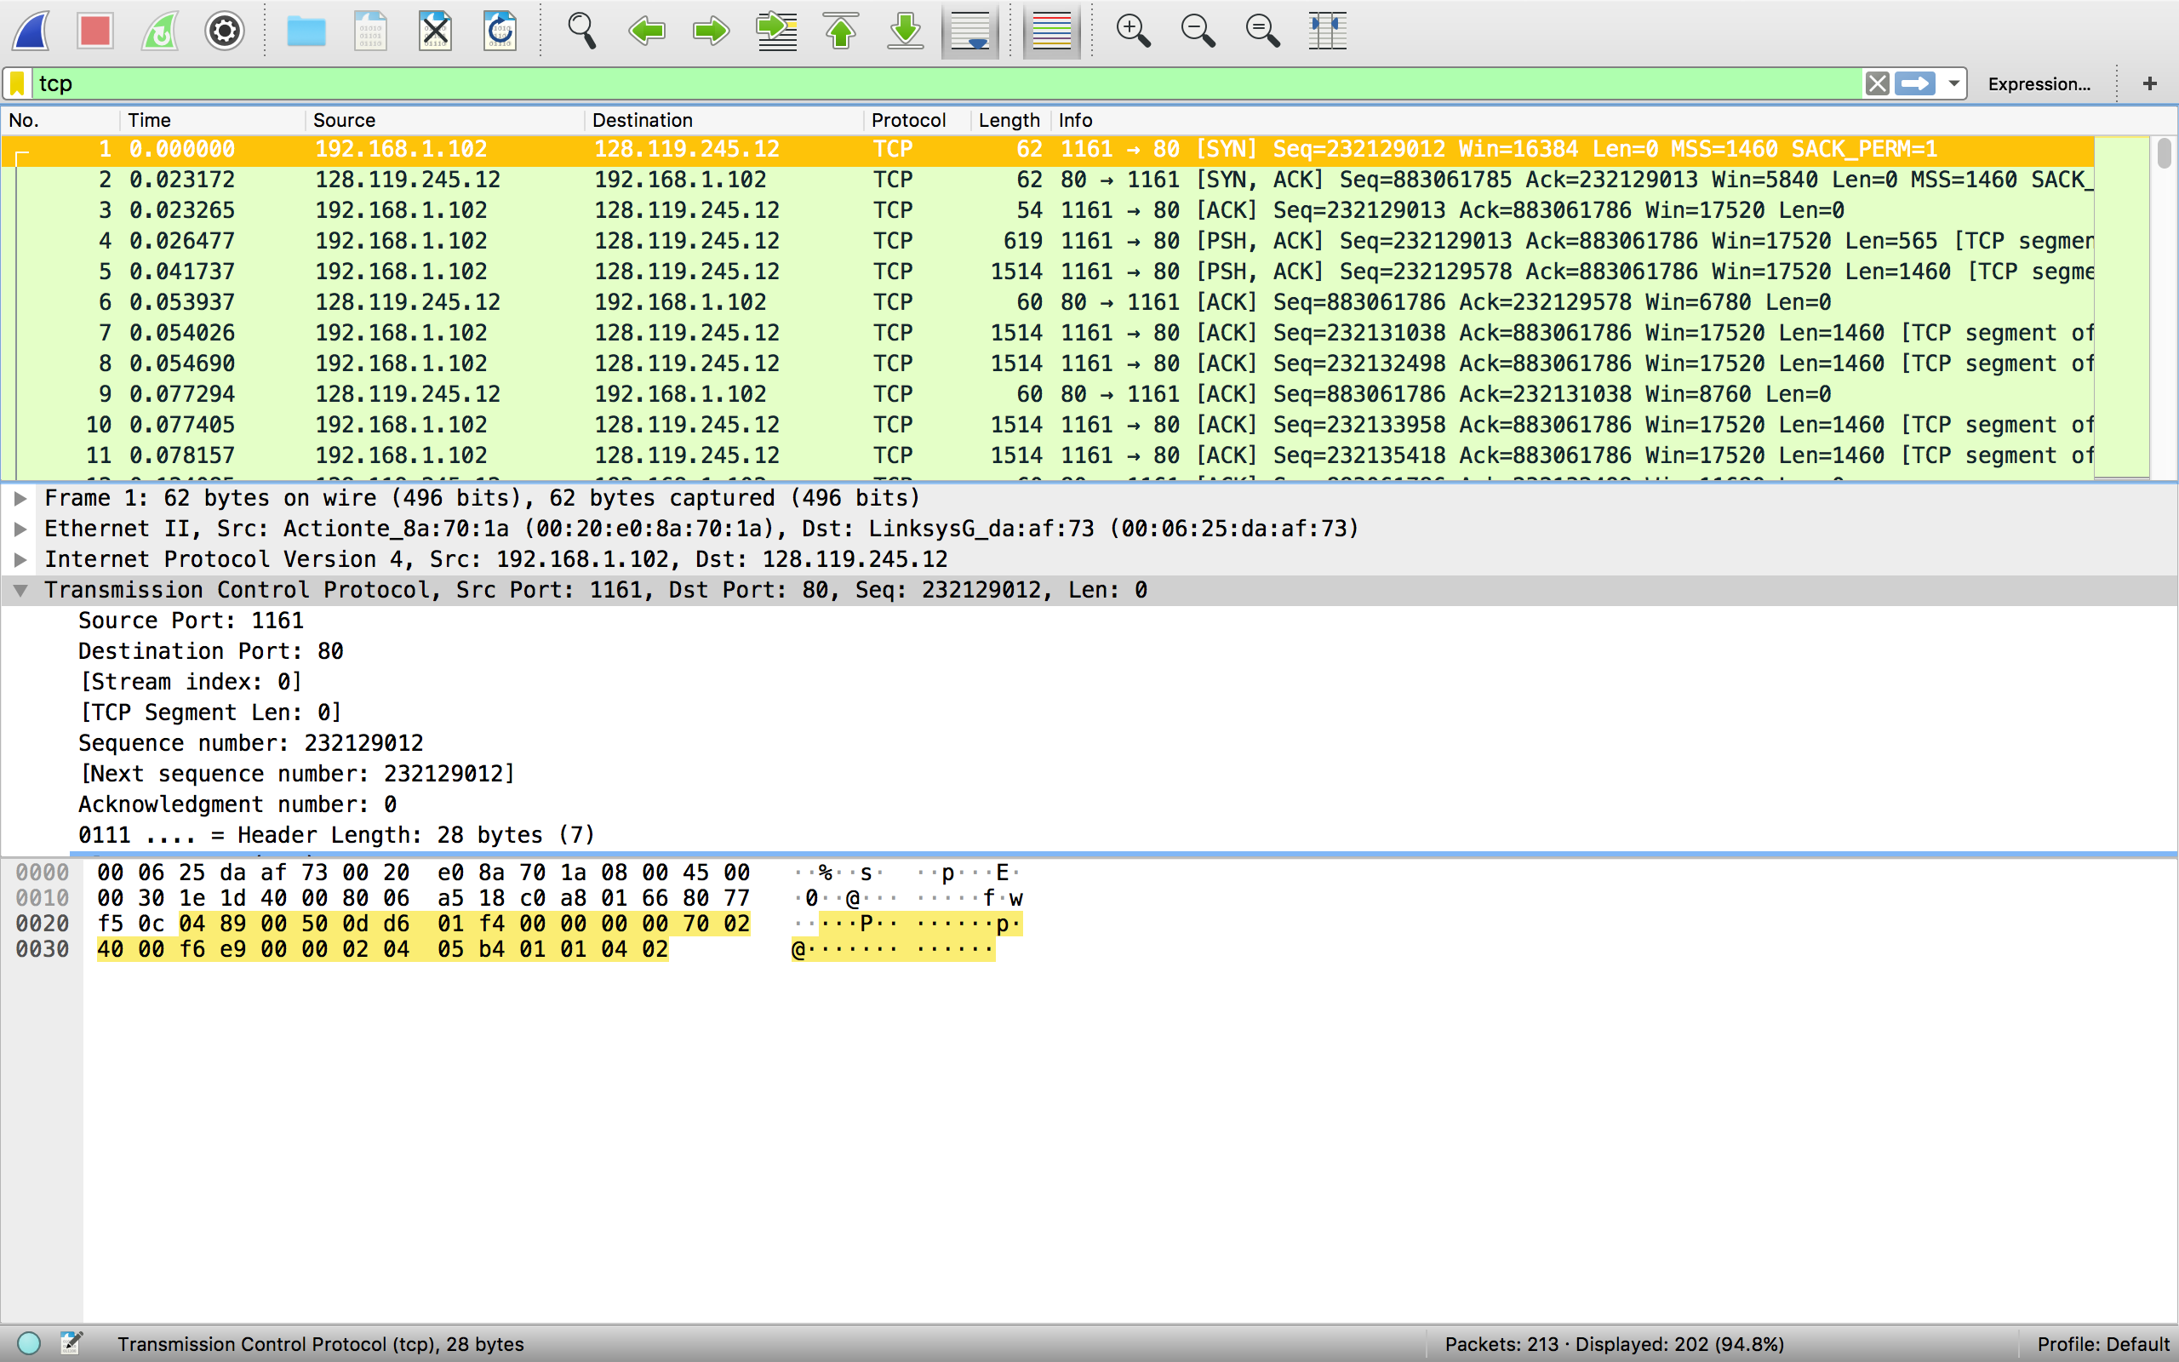

The IP address of gaia.cs.unmass.edu is 128.119.245.12.

Sending and receiving TCP segments on port 80.

The IP address and TCP port used by the client computer is 192.186.1.102, port 1161.

***Question 2.*** *What is the sequence number of the TCP segment containing the HTTP POST command?*

The 4th segment contains the HTTP POST command and the sequence number is 232129013.

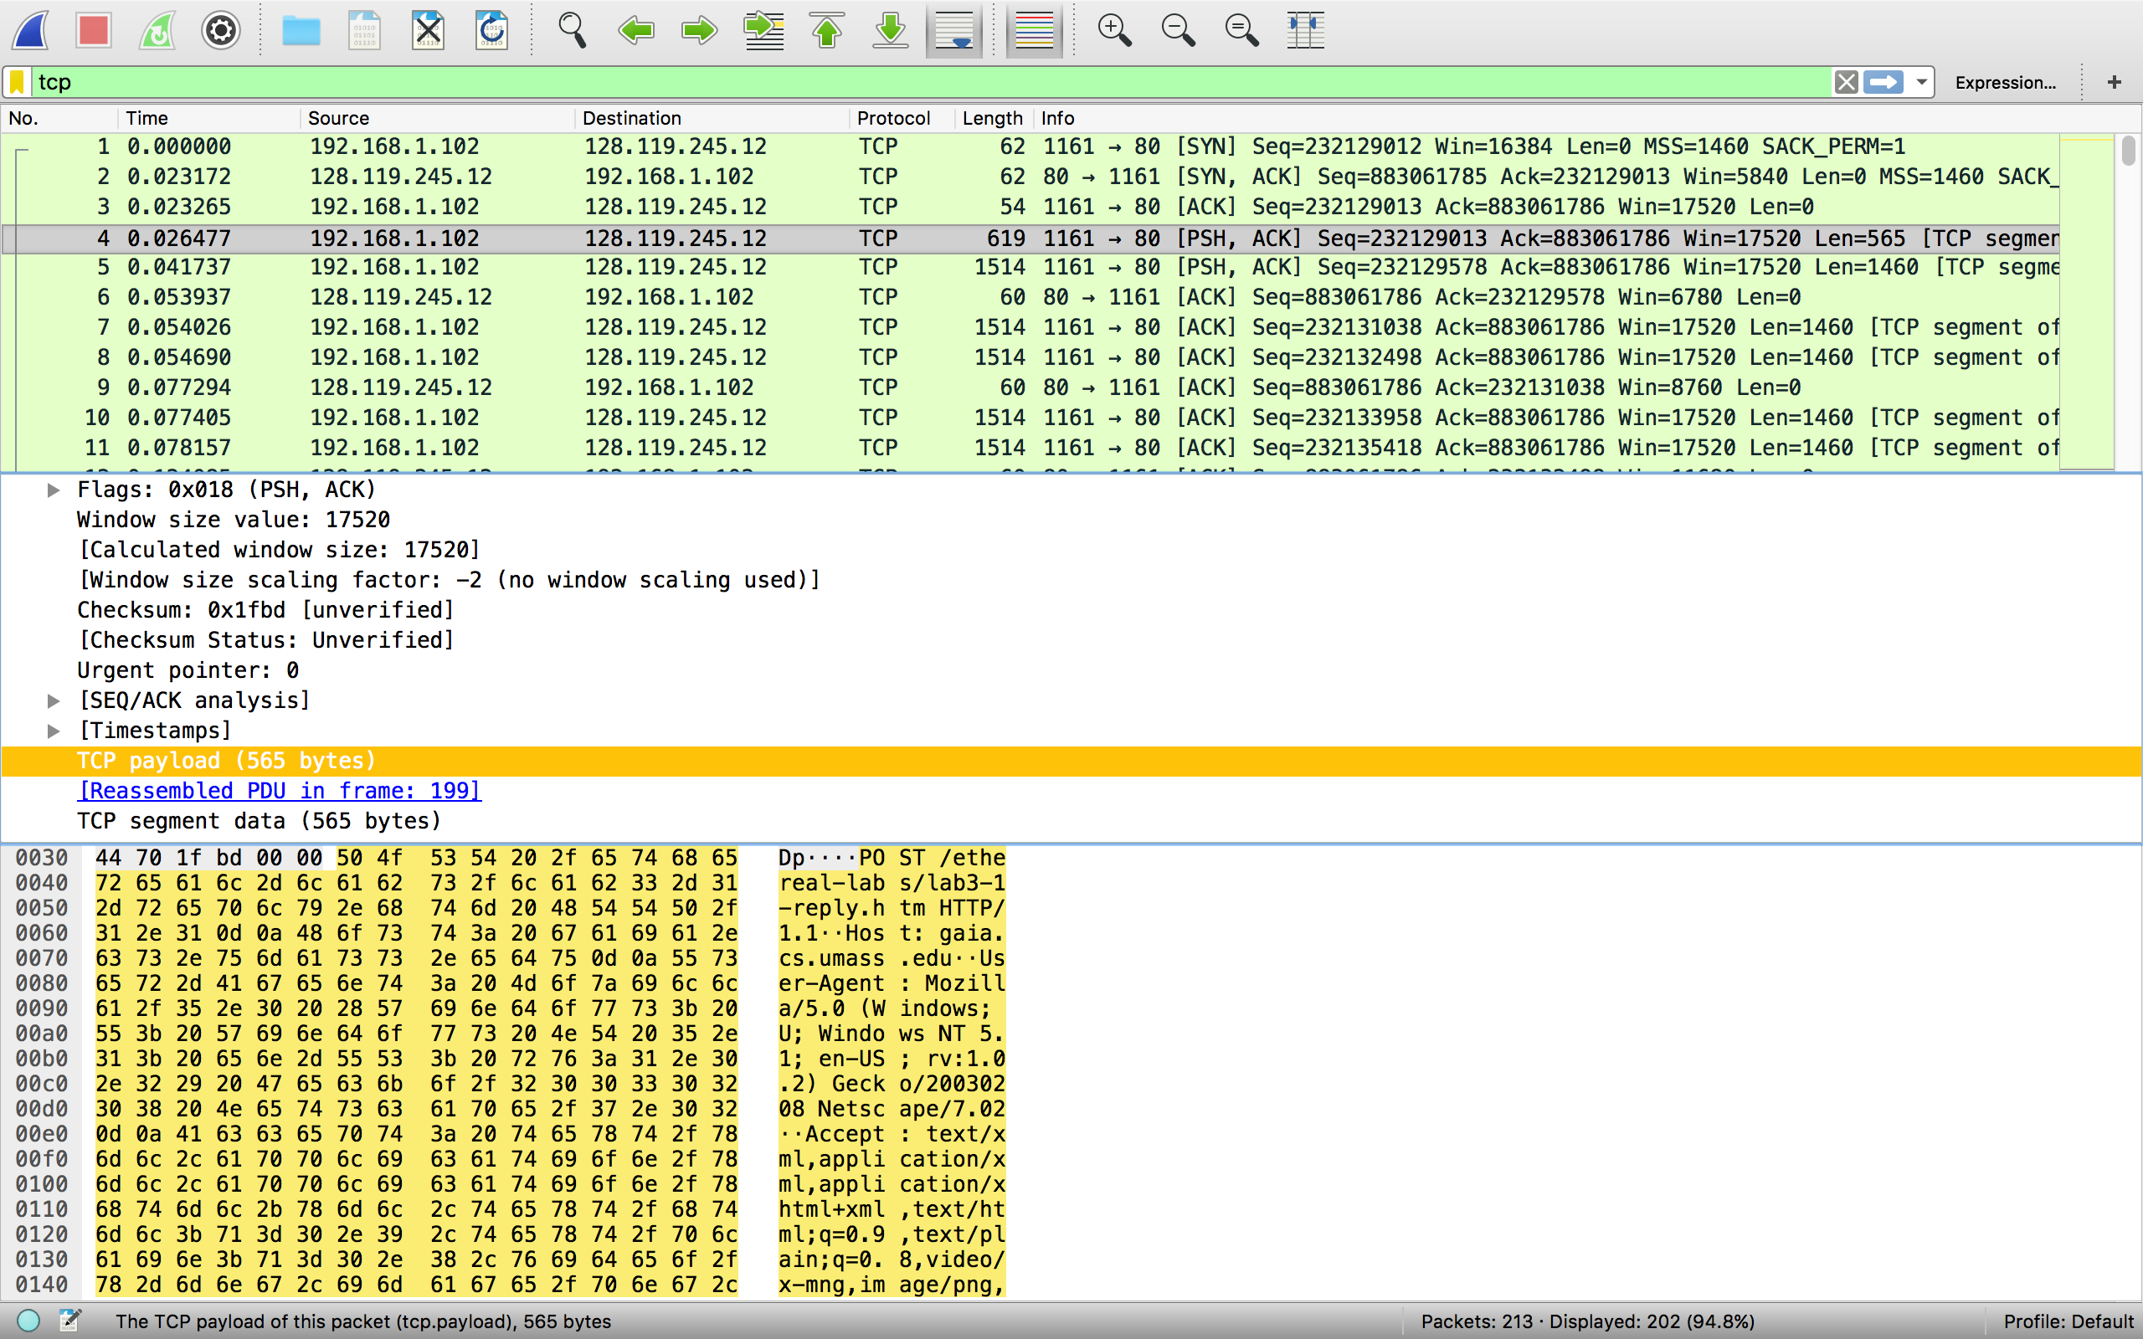

***Question 3.*** *Consider the TCP segment containing the HTTP POST as the first segment in the TCP connection. What are the sequence numbers of the first six segments in the TCP connection from the client to the web server? At what time was each segment sent? When was the ACK for each segment received? Given the difference between when each TCP segment was sent, and when its acknowledgement was received, what is the RTT value for each of the six segments? What is the EstimatedRTT value after the receipt of each ACK?*

|  |  |  |  |  |
| --- | --- | --- | --- | --- |
| Seq number | TCP segment sent | ACK received | RTT | Estimated RTT |
| 232129013 | 0.026477 | 0.053937 | 0.027460 | 0.027460 |
| 232129578 | 0.041737 | 0.077294 | 0.035557 | 0.028472 |
| 232131038 | 0.054026 | 0.124085 | 0.070059 | 0.033670 |
| 232132498 | 0.054690 | 0.169118 | 0.114428 | 0.043765 |
| 232133958 | 0.077405 | 0.217299 | 0.139894 | 0.055781 |
| 232135418 | 0.078157 | 0.267802 | 0.189645 | 0.072514 |

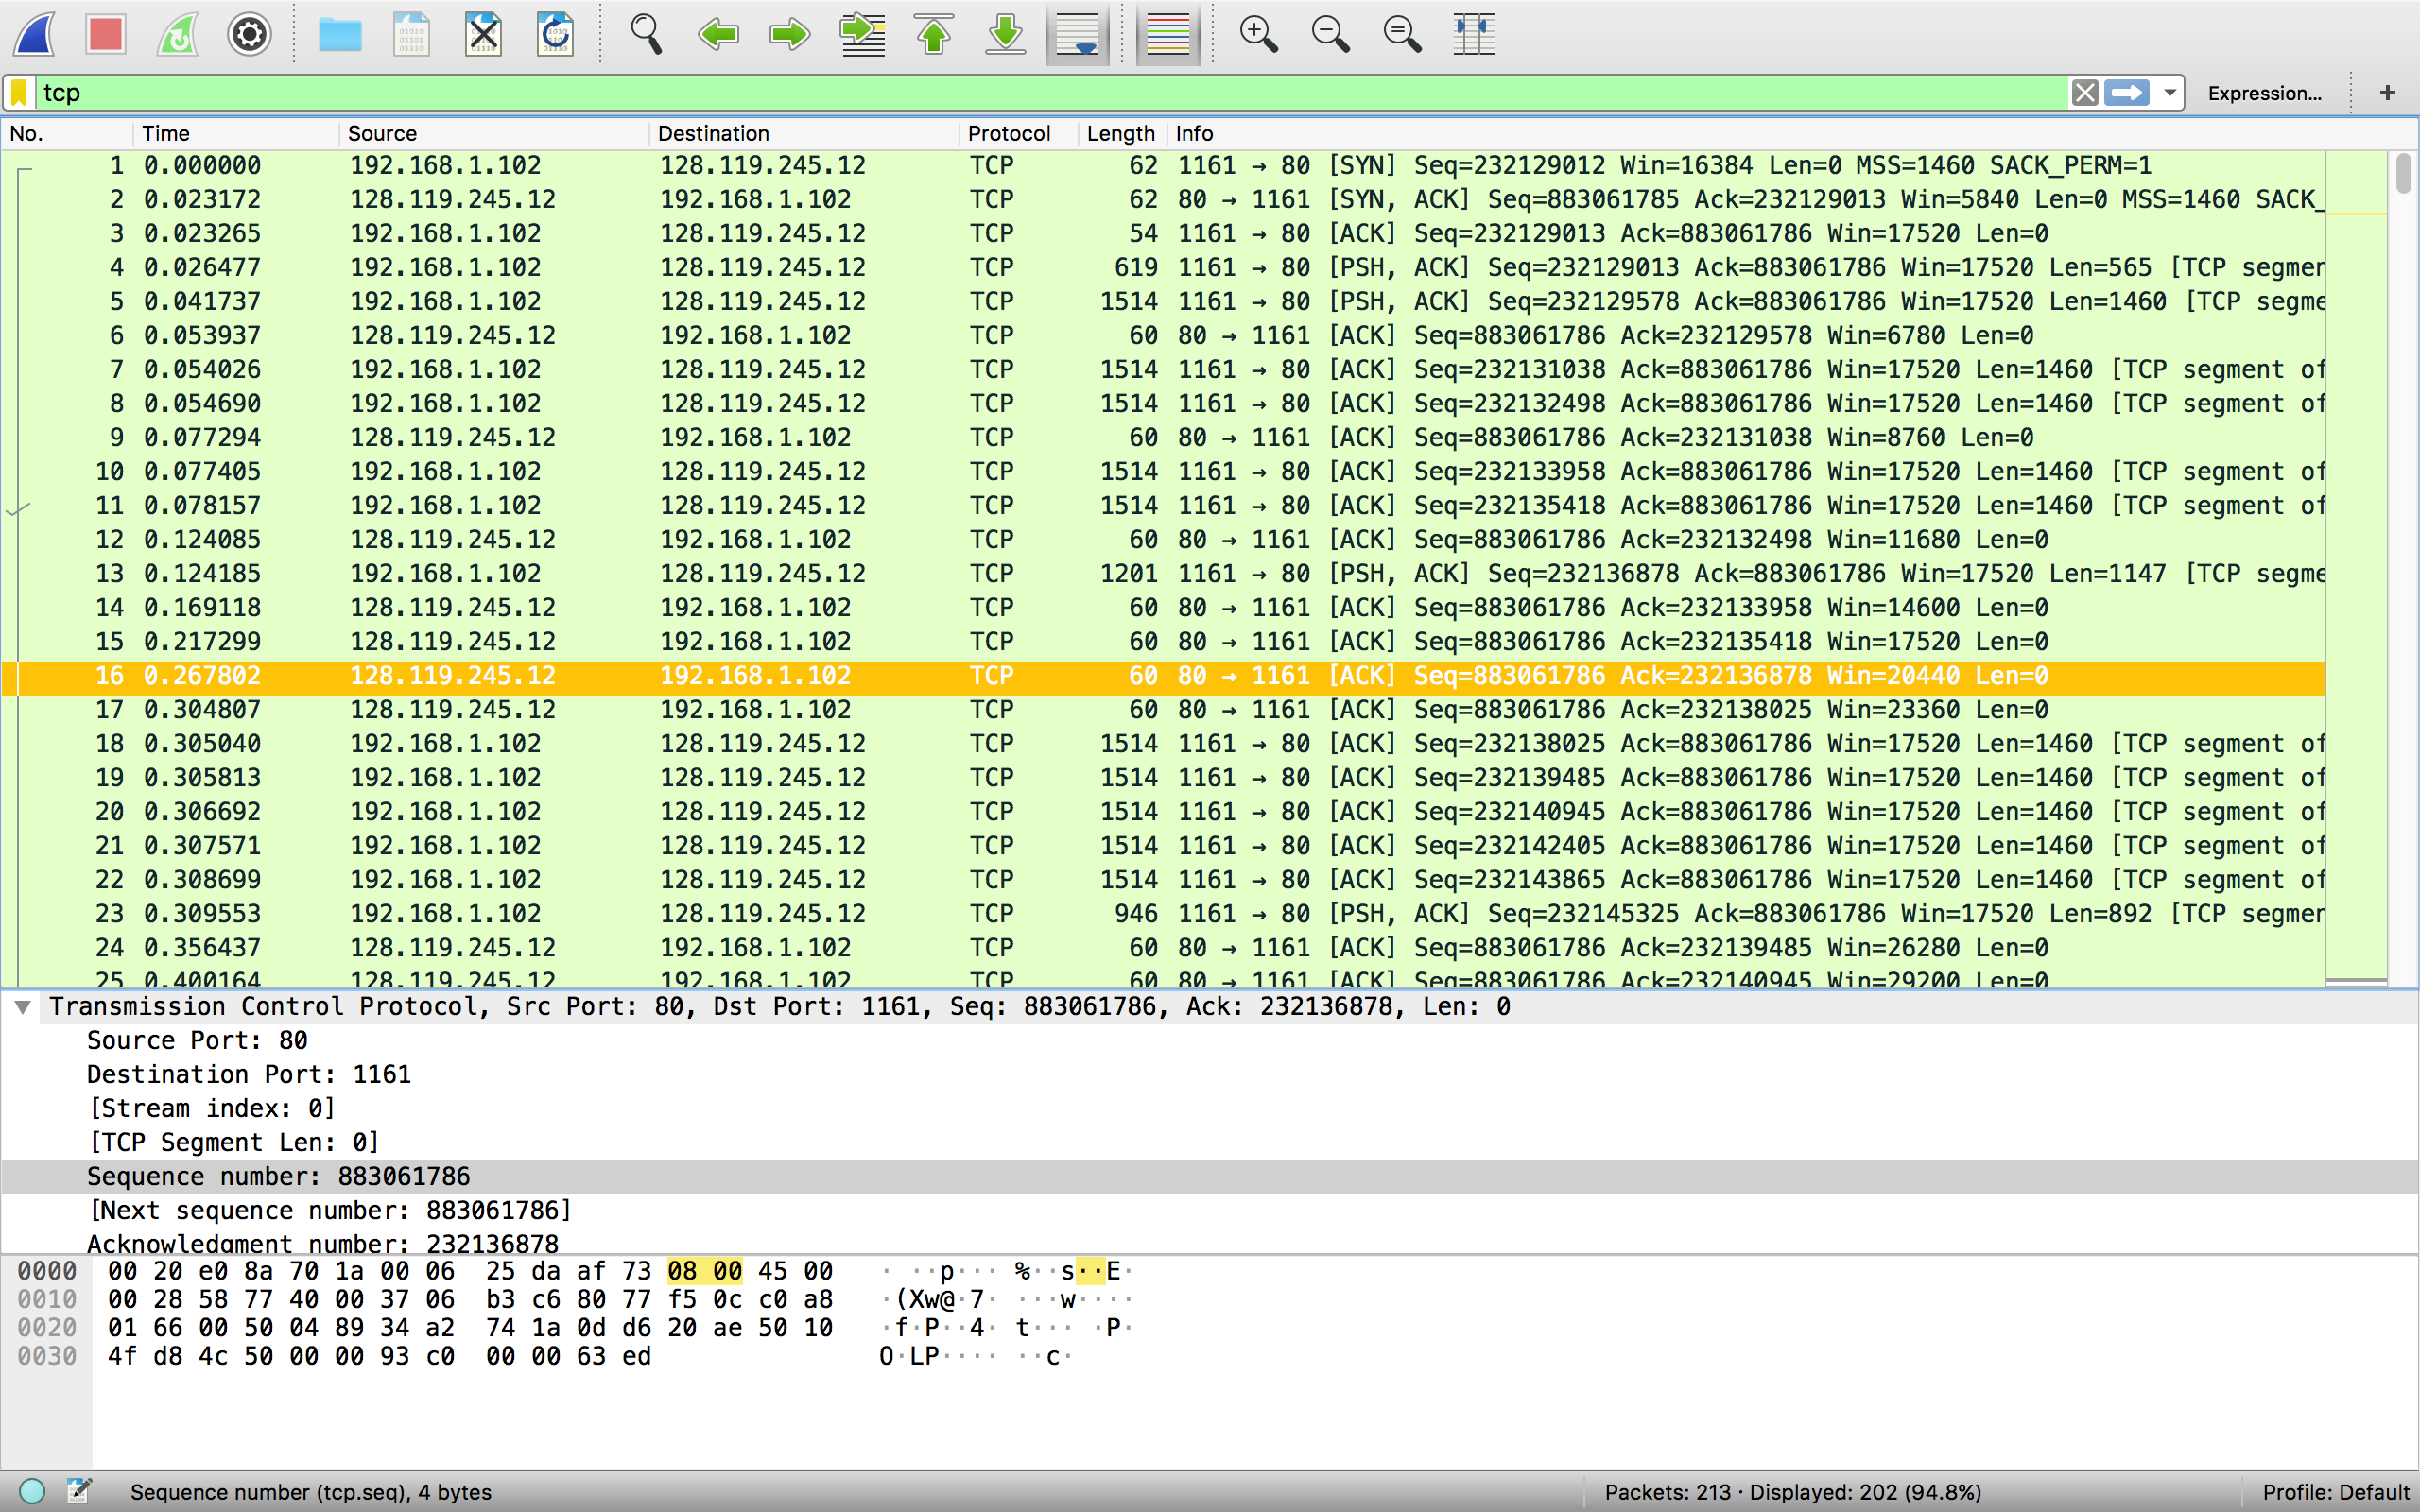

***Question 4.*** *What is the length of each of the first six TCP segments?*

|  |  |
| --- | --- |
| Seq number | TCP segment length |
| 232129013 | 565 |
| 232129578 | 1460 |
| 232131038 | 1460 |
| 232132498 | 1460 |
| 232133958 | 1460 |
| 232135418 | 1460 |

***Question 5.*** *What is the minimum amount of available buffer space advertised at the receiver for the entire trace? Does the lack of receiver buffer space ever throttle the sender?*

The minimum amount of available buffer space is 5840 bytes.

As the buffer space is always larger than segment size, there is no lack of receiver buffer space ever throttle the sender.

***Question 6.*** *Are there any retransmitted segments in the trace file? What did you check for (in the trace) in order to answer this question?*

I check if there are different packets with same sequence number.

And there is no retransmitted segment.

***Question 7.*** *How much data does the receiver typically acknowledge in an ACK? Can you identify cases where the receiver is ACKing every other received segments.*

Typically, the receiver acknowledge that data length is 0 bytes.

***Question 8.*** *What is the throughput (bytes transferred per unit time) for the TCP connection?*

The transfer time is 5.455830 – 0.026477 = 5.429353 sec

The total data is 232293103 - 232129013 = 164090 byte.

So the throughput is 164090 / 5.429353 = 30222.754 byte/sec

**Exercise 2: TCP Connection Management**

***Question 1.*** *What is the sequence number of the TCP SYN segment that is used to initiate the TCP connection between the client computer and server?*

The sequence number is 2818463618.

***Question 2.*** *What is the sequence number of the SYNACK segment sent by the server to the client computer in reply to the SYN? What is the value of the Acknowledgement field in the SYNACK segment? How did the server determine that value?*

The sequence number is 1247095790.

The value of the ACK field is 2818463619.

The sequence number of the SYN segment sent by the client is 2818463618, so the ACK of SYNACK should be 2818463618 + 1 = 2818463619

***Question 3.*** *What is the sequence number of the ACK segment sent by the client computer in response to the SYNACK? What is the value of the Acknowledgment field in this ACK segment? Does this segment contain any data?*

The sequence number is 2818463619.

The value of the ACK field is 1247095791.

This segment doesn’t contain any data.

***Question 4.*** *Who has done the active close? client or the server? how you have determined this? What type of closure has been performed? 3 Segment (FIN/FINACK/ACK), 4 Segment (FIN/ACK/FIN/ACK) or Simultaneous close?*

The client and the server both close the connection.

The first FINACK is sent by the client.

The closure type is simultaneous close.

***Question 5.*** *How many data bytes have been transferred from the client to the server and from the server to the client during the whole duration of the connection? What relationship does this have with the Initial Sequence Number and the final ACK received from the other side?*

The data transfer period is NO.298, 301, 302 and 303.

The sequence number of 298 is 2818463619 while ACK is 1247095791.

The sequence number of 303 is 2818463652 while ACK is 1274095831.

The data transfer from the client to the server is 2818463652–2818463619=33.

The data transfer from the server to the client is 1274095831–1247095791=40.

From the client to the server, the initial sequence number is 2818463618, and final ACK received from the other side is 2818463652. It is the data transferred add 1 byte SYN.

From the server to the client, the initial sequence number is 1247095790, and final ACK received from the other side is 1274095831. It is the data transferred add 1 byte SYN.